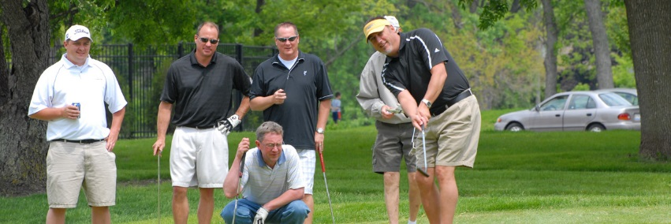
31st Annual
36 hole, 3 Man scramble!!!
Saturday/Sunday, August 6th and 7th
(practice round may be played between 8/1 and 8/5, pay twilight fee only)
*6 Flights based on full field of 72 teams
*Payouts 1st- 4th with 70% cash option
8 AM and 1:30 pm Shotgun starts (36 teams each)
Limited to the first 72 paid teams
$390/$420 (Member/Non-Member) per team (if paid by check or cash, no entry accepted w/o payment
Skins game and proximities optional ($20 per player)
(teams whose members are over 65 will have a separate skins pool)
tees, 64 and under blue, 65+ white
Appropriate golf attire required
Name email phone D.O.b
Player 1 ________________________________________________________
Player 2 ________________________________________________________
Player 3 ________________________________________________________
Entries must be accompanied with payment no later than 7/25/2022
Make checks payable to:
Bent creek golf course
2200 bent Creek dr
Jackson, mo 63755
573-243-6060

