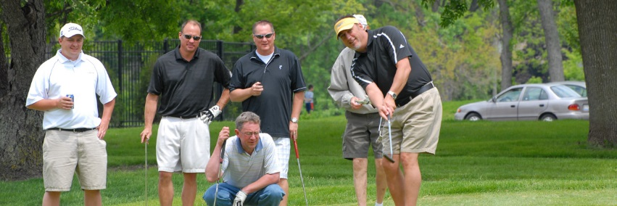
34th Annual
36 hole, 3 Man scramble!!!
Saturday/Sunday, August 5 and 6
(practice round may be played between 8/1 and 8/4, pay cart fee only)
*6 Flights based on full field of 72 teams
*Payouts 1st- 4th with 70% cash option
8 AM and 1:30 pm Shotgun starts (36 teams each)
Limited to the first 72 paid teams
$390/$420 (Member/Non-Member) per team (3% fee applied for CC’s) no entry accepted w/o payment
Skins game and proximities optional ($60/team) Saturday only
(teams with all players over 65 will have a separate skins pool)
Sat. tees, 64 and under blue, 65+ white – Sun. blue/white or white/green based upon flight/age
Appropriate golf attire required/”bump rule” in effect
Name email phone D.O.b
Player 1 ________________________________________________________
Player 2 ________________________________________________________
Player 3 ________________________________________________________
Make checks payable to: Tee Time Preference Saturday: AM PM (circle one)
Bent creek golf course
2200 bent Creek dr preferred Saturday group pairing: _____________________
Jackson, mo 63755
573-243-6060

