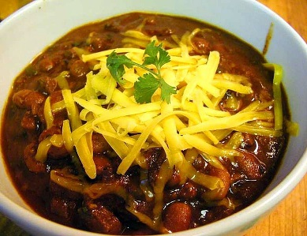

Black Friday-Chili Bowl
4 Player Team Scramble
$20 Member
$40 Public
Skins, proximities and mulligans, $20 team
November 24, 11:00 Shotgun Start
Entries are due by November 17
Includes Golf, Range, Prizes, and Chili Lunch
Player 1_____________________________________
Player 2 ____________________________________
Player 3 ____________________________________
Player 4 ____________________________________
Phone _______________________
Email ______________________________________
Bent Creek golf course
2200 bent creek dr., Jackson MO 63755
Phone 573-243-6060 www.bentcreekgc.com

