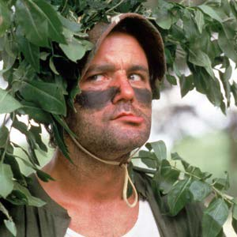
Superintendent’s Revenge
4 Player Team Scramble
The Hardest Setup Imaginable, No Complaining!
$25 member
$40 Non-member
November 3rd, 10:00am Shotgun
Includes: 18 holes, lunch, range balls, drink specials
Optional skins game and closest to pin, $20 team
Player 1_____________________________________
Player 2 ____________________________________
Player 3 ____________________________________
Player 4 ____________________________________
Phone _______________________
Email ______________________________________
Bent Creek golf course
2200 bent creek dr., Jackson MO 63755
Phone 573-243-6060 www.bentcreekgc.com

