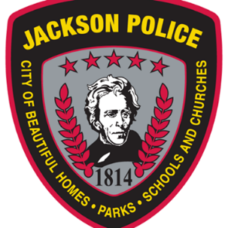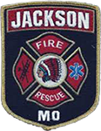
BATTLE OF THE BADGES Golf Outing!
Friday, August 18, 2023, 1PM Shotgun
Hosted at Bent Creek Golf Course, presented by
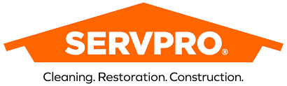
“Like it never even happened.”
4 Player Team Scramble
$340 per team, $400 with sponsor sign
11:30 Lunch sponsored by
Includes: Golf, Range, Lunch and Prizes
Optional: course games/mulligans/skins $40.00 per team
Player 1_______________________ Phone/EMAIL ___________________________
Player 2 _______________________ Flight: Police dept. __ Fire dept. __
Player 3 _______________________
Player 4 _______________________
Bent Creek golf course
2200 bent creek dr., Jackson MO 63755 Phone 573-243-6060 www.bentcreekgc.com

Hole in One Sponsor Form
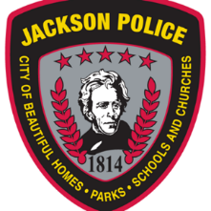
BATTLE OF THE BADGES GOLF OUTING
Benefiting Jackson’s First Responders!
August 18, 2023, Bent Creek Golf Course
PRESENTED BY:
“Like it never even happened.”
LUNCH Sponsored by

Hole in One Sponsor (up to 4 available): Sponsor company will pay the insurance policy premium to provide a $10,000 or $25,000 or a vehicle (at it’s discretion), should any player make a hole in one on a given hole. Sponsor will also provide witnesses, chairs and shelter (if desired) or Bent Creek will provide a golf cart for volunteer use. Sponsor may also bring giveaway items for golfers if they wish. Insurance cost will vary with value of prize. Bent Creek will assure that required yardages are met.

Company name: _________________________________

Authorized signature: _______________________________

Printed name: ________________________________

Amount of prize: $___________________ or Vehicle Type: __________________________

Sponsor Form
2nd Annual, BATTLE OF THE BADGES GOLF OUTING
Benefiting Jackson’s First Responders!
August 18, 2023, Bent Creek Golf Course
PRESENTED BY:
“Like it never even happened.”
LUNCH Sponsored by

Sponsor Commitment by 8/1!

FIRST RESPONDER Sponsorship: $300 Inclusion on FIRST RESPONDER Sponsor Banner, Program recognition, announcement recognition and large Tee Sign.

BADGE Sponsorship: $250 Inclusion on BADGE Sponsor Banner, Program Recognition and Tee Sign.

TEE sign: $100

Company Name (as it will appear): _______________________________________
Authorized Signer (Print): _______________________________
Signature: _________________________________
Date: _______________ Check#: _____________

BATTLE OF THE BADGES Golf Outing!
Friday, August 18, 2023, 1PM Shotgun
Hosted at Bent Creek Golf Course, presented by
“Like it never even happened.”
4 Player Team Scramble
$340 per team, $400 with sponsor sign
11:30 Lunch sponsored by

Contact:
Bent Creek Golf Course, 573-243-6060 x 2, to sign up your team,
or become a sponsor;
Or download the application at
Bentcreekgc.com (Events Registration Page)

